To make your own RISK II dice:

First, it is necessary to buy 12-sided dice of 5 different colors. The colors the PC game uses are white, yellow, orange, red, and black. For reasons of contrast, I replaced my orange dice with green, and this is reflected in the rules. I recommend buying at least three of each color, though theoretically you might need up to seven of the same color. To save time and work, I only purchased and made three, and use standard six sided dice to sort of mark which numbers have already been rolled, should I need more than three of the same color.

Next, you need small circular stickers, the same colors as each of the dice. If these are unavailable, several larger colored stickers are available and easy to obtain. Simply use a hole puncher to get the smaller stickers you need. In the case of the black dice, I used white stickers. Other than that, I stuck with the same color.

Cover all numbers on all sides of the dice with the colored stickers. Then carefully number the dice with the appropriate number of each value. Use the following chart to see how many 1’s through 6’s go on each color of die.

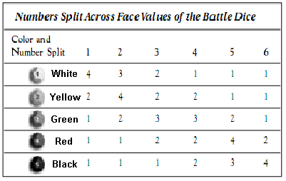

In other words, put four 1’s on the white die, three 2’s, two 3’s, one 4, one 5, and one 6. Follow the chart for all your dice. I tried to space all numbers apart from each other, but it’s not always possible. As long as you have the proper values on your dice, it doesn’t really matter. And now you have your battle dice!

